Images of our 2018 June journey to the Hedges on Blue Mtn. Lake, NY

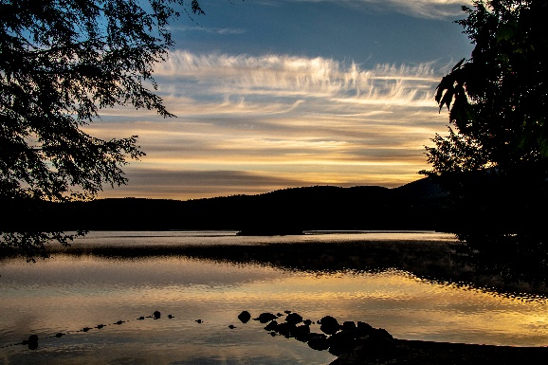

It began in the summer of 1994. Since then we have visited The Hedges annually on various dates and seasons. This trip to The Hedges on Blue Mountain Lake happened in June. The weather was excellent and we were fortunate enough to have all out kids and grandkids join us for a long weekend. We had a lot of outside activities and did manage a photo or two for our memories.

For the photos, click [The Hedges – June 2018](https://photos.app.goo.gl/3g6HzyavVT96k3i4A).